

**National University**



of Computer



and



Emerging Sciences



Chiniot



-



Faisalabad Campus



**EE1005 – Digital Logic Design**

**Quiz# 5**

**Instructor:** Muhammad Adeel Tahir **Section:** SE-2B **Time:** 60 Minutes

**Name: _____________________________**

**Roll No: ____________________________ Total: 25+10+35= 65 marks**

***Instructions:*** *Make sure the handwriting is neat and clean while drawing the circuit, quiz will be marked as 0 if attempted in a writing that is not readable at all.*

**Question 1:** Create a digital game design titled "Pakistan Voice Idol Game". This simulation involves a competition setting with four judges. Each judge has the ability to vote for a contestant. A vote is represented as HIGH (indicating approval), while the absence of a vote is represented as LOW. Your task is to design a system using an 8x1 Multiplexer and basic logic gates where a contestant is deemed a winner and triggers a "winning light" to turn ON only when they receive the maximum possible votes from the judges. If the contestant does not receive the maximum votes, the winning light should remain OFF, indicating they were not selected. Consider how you can effectively use the multiplexer and logic gates to process the judges' votes and display the outcome. Complete your design by: **[2+5+3=15]**

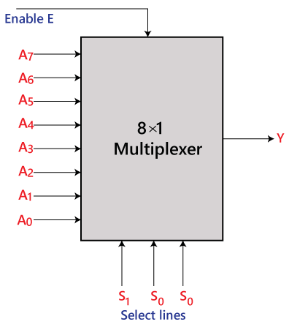**No of Inputs**_________ **No of Outputs**________

|  |  |  |  |  |  |
| --- | --- | --- | --- | --- | --- |
|  |  |  |  |  |  |
|  |  |  |  |  |  |
|  |  |  |  |  |  |
|  |  |  |  |  |  |
|  |  |  |  |  |  |
|  |  |  |  |  |  |
|  |  |  |  |  |  |
|  |  |  |  |  |  |
|  |  |  |  |  |  |
|  |  |  |  |  |  |
|  |  |  |  |  |  |
|  |  |  |  |  |  |
|  |  |  |  |  |  |
|  |  |  |  |  |  |
|  |  |  |  |  |  |

**Question 2:** Using a decoder and external gates, design the combinational circuit defined by the following

three Boolean functions & identify the minterms: **[3+3+3+1 = 10 marks]**

**Working:**

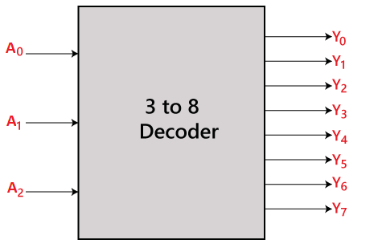

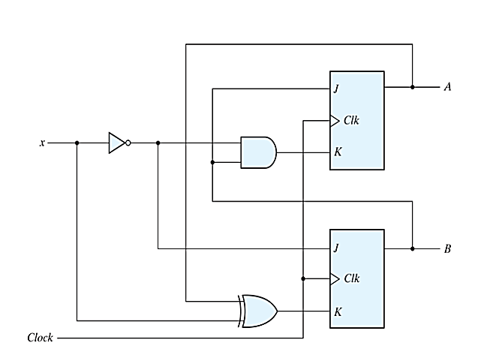**Question 3:** Given below is the circuit diagram of a synchronous (same clock is applied to both flip flops) sequential circuit with two flip flops (JK), one input x, and no output. Analyze the given circuit to find the: **[2+5+3=10 Marks]**

* State Equation(s)
* State Table
* State Diagram

**State Diagram: (no cutting allowed)**

|  |  |  |  |  |  |  |  |
| --- | --- | --- | --- | --- | --- | --- | --- |
|  | |  |  |  |  | |  |
|  |  |  |  |  |  |  |  |
|  |  |  |  |  |  |  |  |
|  |  |  |  |  |  |  |  |
|  |  |  |  |  |  |  |  |
|  |  |  |  |  |  |  |  |
|  |  |  |  |  |  |  |  |
|  |  |  |  |  |  |  |  |
|  |  |  |  |  |  |  |  |
|  |  |  |  |  |  |  |  |

**State Equation(s):**

**Working:**

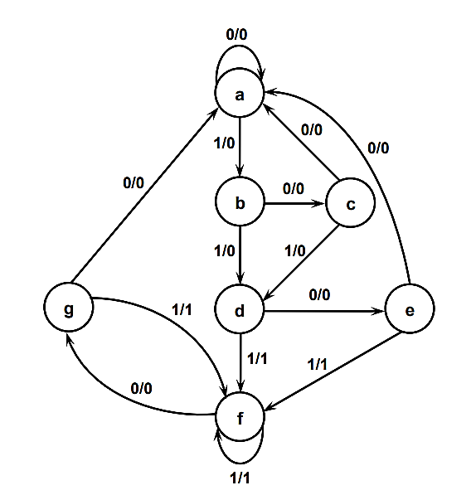**Question 4:** Given the following State diagram, perform the following **[2+4+4=10 marks]**

a) Construct the state table that corresponds to the given state diagram.

b) Reduce the state table to its minimized form step by step.

c) Redraw the reduced state diagram

|  |  |  |  |  |
| --- | --- | --- | --- | --- |
| **State Table (binary checking- no cutting allowed)** | | | | |
|  |  | |  | |
|  |  |  |  |
|  |  |  |  |  |
|  |  |  |  |  |
|  |  |  |  |  |
|  |  |  |  |  |
|  |  |  |  |  |
|  |  |  |  |  |
|  |  |  |  |  |
|  |  |  |  |  |

**State Diagram (No cutting allowed)**

**Question 5: Design a sequential circuit with two JK flip-flops A and B and two inputs E and F. The circuit will follow some conditions that are broken down for you as followed for the ease of readability: [10+5+5 = 20 marks]**

1. **When E = 0:**
   * The circuit should maintain its current state, regardless of changes in F.
2. **When E = 1 and F = 1:**
   * The circuit will cycle through the following state transitions:

Start from 00 🡪 01 🡪 10 🡪 11 🡪 00. This cycle should repeat.

1. **When E = 1 and F = 0:**
   * The circuit will cycle through a different set of state transitions:
     + Start from 00, 🡪 11 🡪 10 🡪 01 🡪 00. This cycle should repeat.

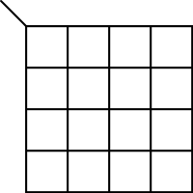**Fill the table for this sequential circuit. Find the corresponding equations using k-maps, and draw the sequential circuit in neat and clean way**.

|  |  |  |  |  |  |  |  |
| --- | --- | --- | --- | --- | --- | --- | --- |
|  | |  | |  |  |  | |
|  |  |  |  |  |  |  |  |
|  |  |  |  |  |  |  |  |
|  |  |  |  |  |  |  |  |
|  |  |  |  |  |  |  |  |
|  |  |  |  |  |  |  |  |
|  |  |  |  |  |  |  |  |
|  |  |  |  |  |  |  |  |
|  |  |  |  |  |  |  |  |
|  |  |  |  |  |  |  |  |
|  |  |  |  |  |  |  |  |
|  |  |  |  |  |  |  |  |
|  |  |  |  |  |  |  |  |
|  |  |  |  |  |  |  |  |
|  |  |  |  |  |  |  |  |
|  |  |  |  |  |  |  |  |
|  |  |  |  |  |  |  |  |

**Diagram & Working (if any):**

**Bonus:**

What goes up but never comes down?_________ **(2 marks)**